

Team A – Ai Stead Mai Date/Outing Ideas App

CTD_1D = {

"Team": "A",

"Project Name": "AI Stead Mai",

"Members": [ "Robin", "Minghui", "Jiarong", "Rayne", "Charlie", "Kieran" ],

"Student ID": [ 1007212, 1006892, 1007056, 1007044, 1007154, 1006900 ]

}

**Scenario**

By compiling the best things to do all over Singapore and including a filter function, Ai Stead Mai was created for youths and adults of ages 18-35 looking for things to do in Singapore. Specifically in the case of Jiarong, who is a teen who struggles to find the right activity to do at the most appropriate and convenient time, whether it is with her friend groups or her boyfriend. Oftentimes, young adults struggle to find the perfect group activity or date and require a lot of time and planning just to enjoy a day out. Ai Stead Mai suggests the perfect date or outing based on the specific filters required by the user, saving precious time and removing the stress factor that can ruin what is meant to be relaxing or fun.

**Description**

The app prompts the user with a Tkinter interface with buttons as filters for them to narrow down the options to suit their needs better. For example, if a group of 3 friends are in the East would like to find something to do in the price range of “$$” (a gauge of price range), the filters narrow the options down to things to do in the East for “$$” for a group of 3. Ai Stead Mai’s filters and features include a randomizer feature, filter by occasion, location, time range for activity and price. The app currently has over 100 suggested activities. Additionally, clicking on the suggested activity will direct the user to Google. This is useful as Google itself does not have a filtered search function. There is also a search function within the app that can take the user directly to the specific activity they may be looking for.

**Documentation**

|  |
| --- |
| It is required for the application to use **tkinter**, **pillow**, and **url** libraries for the design. Also, **random** and **webbrowser** for background changing colour, random event button, and to open a google link which searches the activity according to its ‘Title’.  The code starts with, **with open("****ctd_planning.****csv","r") as f: ,** which opens and reads a csv file that contains all the activities information. These activities are then stored in a nested dictionary for later use.  The format of csv file is:  Title, pax_min, pax_max, Occasion, Location, time_min, time_max, Price, Image  Sentosa luge, 2, 8, Date/Friends, Sentosa, 1, 2, $$, “Image URL Link”  **randomcolor()**: This function randomizes the colour as decimals and returns its hex value as a string  **filtering(category)**: This function displays a new window which displays filtering options when one of the filter buttons is clicked. It takes in a category for processing and displays their own design accordingly. When input is keyed in or filter option is chosen, it calls **filtering2(category, input2)** function which takes in the information about pax, time, occasion, location or price.  **filtering2(category, input2)**: This function changes each of the button names to its selected filtering options. If the inputs are invalid or out of range, a messagebox will pop up and show warning that their filter is not valid and cancels their input for them to try again. The CLEAR FILTER button also uses this function to reset the filter buttons names.  **filtering3()**: This function reads all the button names to get the user chosen filter options. Checks the dictionary that contains all the possible activities and filter it into a new dictionary for display.  **display()**: This function displays all the possible places to go as individual buttons for display using the filtered dictionary. Using the function **filtering3()** to do the filtering.  **func(x=key)**: This function is used to keep track of each key as every button has its own unique key  **display2()**: This function displays detailed information (planning) about selected button (places)  **reload()**: This function refreshes the window every 10 seconds to change background colour randomly. Uses the function **randomcolor()** to get a hex value string and changes the background of both filter buttons and display.  This is near the end of the code where the skeleton of the design is done;  **window = Tk()** creates window for the whole platform.  **frame1 = Frame(window)** creates frame inside the window. This frame is used to place all the filter buttons, including search, clear and random button.  **frame2 = Frame(window)** creates second frame for the display of activities.  **display()** and **reload()** functions are called for the first time then **window.mainloop()** function which shows the window and all the displays with it. |

GUI

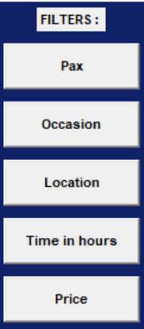 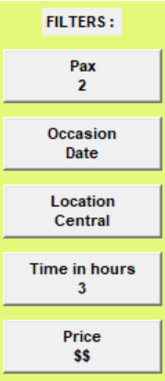

Filter Functions: User filters based on Price, Occasion, Location, Time in hours of the activity and Price, depending on their requirements.

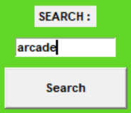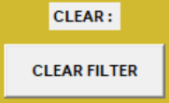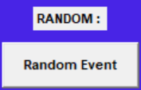

Search Function: User can search a particular activity that he/she may have in mind to find its information

Clear Function: Clears the user input filters

Random Function: Randomly chooses any event from the filtered activities

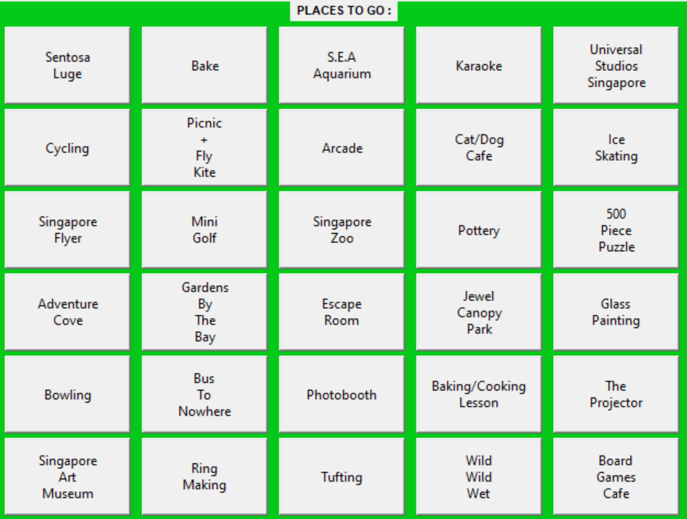

Display Frame: Displays the filtered activities

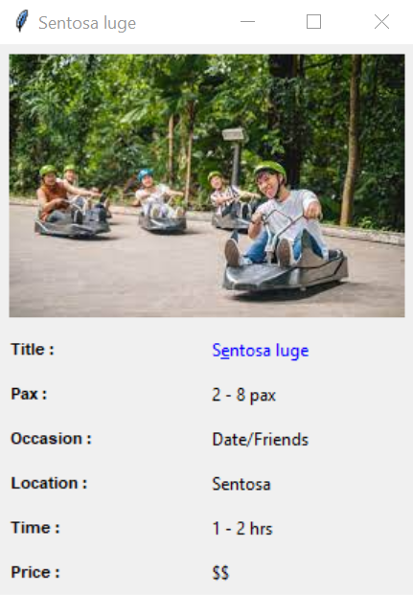

Display Information: When one of the activities are clicked, their information is displayed on another window

**Video Showcase**

[A.I Stead Mai (CDT 1D Project)](https://youtu.be/hcf7uwx1Sp4)

[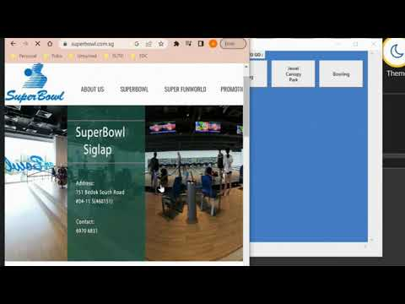](https://youtu.be/hcf7uwx1Sp4)